New Dis-Eur-Czech Republic- Pekárna Höhle-removable haft for a projectile point, 12 940 ± 250 BP

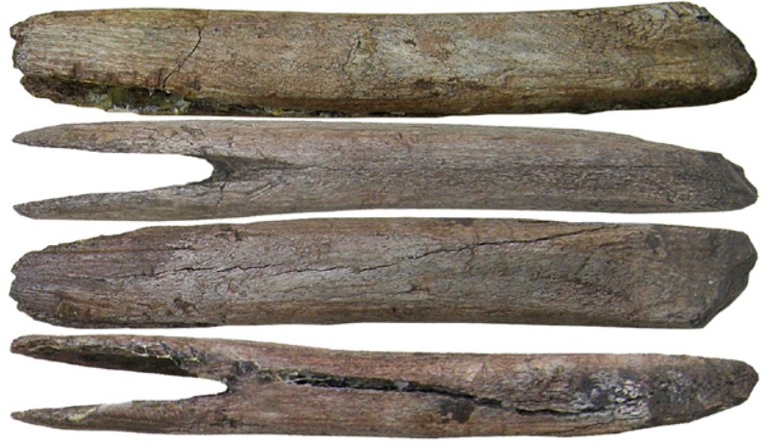 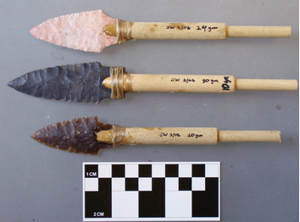

Fig. 1. Czech Republic-Pekárna Höhle- removable haft for a projectile point, 12 940 ± 250 BP.

Fig. 2. Examples of a removable projectile haft

**Formal Label:** Czech Republic-Pekárna Höhle- removable haft for a projectile point, 12 940 ± 250 BP

**Case Description:**

This removable haft for a projectile point, 12 940 ± 250 BP, was an invention of late Magdalenian hunters of the Central European plain as they hunted in river valleys such as the Ochosky Potok valley near Pekárna Höhle in the Czech Republic where this was excavated. With this removable haft one could re-arm the spear or atlatl dart with another point quickly and thus improve the chances of hitting moving prey. It may have developed simultaneously with the introduction of the atlatl.

**Accession Number:**

**LC Classification:** DAW1023 .I58

**Date or Time Horizon:** 12 940 ± 250 - 12 670 ± 80 BP

**Geographical Area:** Czech Republic-Pekárna

**Map, GPS Coordinates:** [49°15′25″N 16°44′19″E](https://tools.wmflabs.org/geohack/geohack.php?pagename=Ochoz_u_Brna&params=49_15_25_N_16_44_19_E_type:city%281290%29_region:CZ)

 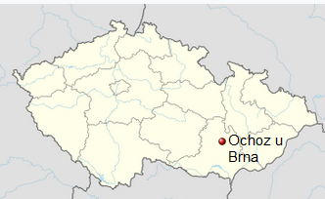

Fig. 3. Magdalenian sites in the Czech Republic Moravian karst: 1. Pekárna, 2. Kůlnička, 3. Mokrá, 4. Křižova, 5. Adlerova, 6. Ochozská, 7. Švédův stůl, 8. Lišči. Measure is in km. From Valoch 2001.

Fig. 4. Location of Pekárna near Ochoz u Brna in the Czech Republic. From https://upload.wikimedia.org/wikipedia/commons/thumb/1/10/Czech_Republic_adm_location_map.svg/375px-Czech_Republic_adm_location_map.svg.png

**Cultural Affiliation:** Magdalenian

**Medium:** bone

**Dimensions: L 11 cm.  
Weight:**

**Provenance: original, Moravian Museum in Brno, Czech Republic.**

**Condition:** Museum replica in resin.

**Discussion:**

This example of a removable haft for projectile points was a major advance over earlier spear technologies such as those using bone harpoons which were permanently affixed to the spear and hence the hunter had only one chance per spear for striking prey. This advance may have occurred simultaneously with the introduction of atlatl technology where dart points on atlatl shafts were discharged at animals at a greater rate than the earlier spear technologies had allowed (Říhovský 1996), so recovery of dart points from this type of removable haft was a great advantage (Stodiek 1993). With this invention one need only carry few spears or atlatl shafts since one could re-arm the spear or atlatl shaft as needed (McClellan and Dorn 2006: 11).



Fig. 5. An artist’s depiction of the use of permanently affixed barbed harpoons by Magdalenian Cro-Magnon reindeer hunters, ca 20,000 BP. From the Moravian Museum, Brno, Czech Republic. <http://creativecommons.org>.

**References:**

Klima, Bohuslav. 1964. *“*Eine neue paläolithische Ritzzeichnung aus der Pekarna-Höhle

in Mähren”. www.quartaer.eu/pdfs/1964/1964-65_09_klima.pdf

McClellan, James Edward, Harold Dorn. 2006. Science and technology in world history: an introduction. Baltimore: Johns Hopkins University Press.

Říhovský, Jiří. 1996. Die Lanzen-, Speer-, und Pfeilspitzen in Mähren. Stuttgart : F. Steiner.

Stodiek, Ulrich.1993. *Zur Technik der jungpaläolithischen Speerschleuder.* Tübinger Monographien zur Urgeschichte, Bd. 9. Tübingen. Archaeologica Venatoria.

Valoch, Karel. 2001. “Das Magdalenian in Mähren 130 Jahre Forshung,” *Jahrbuch des Römisch-Germanischen Zentralmuseums* [Mainz], 48: 103–159.